* **Activity 4:**

Creating Joins with the ON Clause

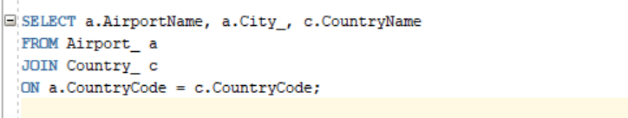

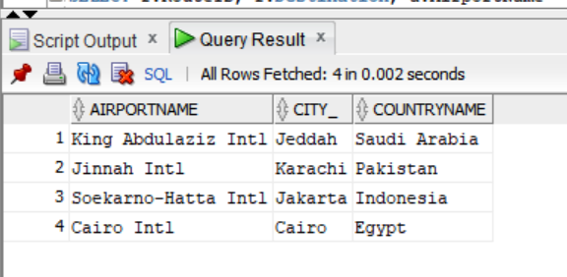OUTPUT: